Coastal Development and Runoff
Sedimentation is a significant potential threat to the reefs of American Samoa. The islands are very steep and rainfall is heavy. The steep slopes are almost completely covered by dense native vegetation, however, some areas are characterized by secondary growth from clearing for agriculture and quarry operation from prehistoric settlement (Clark and Herdrich 1993). If a significant amount of vegetation were to be removed, sediment runoff would increase and have a potential impact on the reefs. A modern day commercial logging and quarry operation would not be economically feasible.

Tutuila, where almost all of American Samoa’s population of over 60,000 people lives, has only about 10 square miles of flat land, almost all coastal. Further, the high population growth rate leads to increasing construction and the use of additional land placing great strains on shoreline resources. The potential impact sedimentation on coral reefs and its resources led DMWR Key Reef Species Program to conduct a quantitative assessment of the sedimentation rates in areas along the south shore of Tutuila to determine it’s effect on sportfish population. Nine sediment traps were deployed and retrieved monthly at the reef slopes of 12 monitoring sites from January 2006 to February 2007. Six sites were located in embayment areas while 6 were at topographic points to account for habitat variability. Two additional sites at the mouth of the stream (Faga’alu and Fagatogo) were included to determine the amount of sediment outputs generated by the stream compared to the slope (inferred sediment dissipation). Dry weight of sediments was taken and sedimentation rates were estimated at grams per cm² per day. Results showed consistently higher sedimentation rates in sites located in bays (where most streams are located; average of 12.1 g/cm²/day) than sites on topographic points (average of 1.4 g/cm²/year) (Figure XXX). Sedimentation rate from the stream, however, is drastically higher than both bay and point sites at 84.7 g/cm²/day). These were considered as detrimental to coral reef while rates at bay and points were considered to have moderate and slight effect, respectively (Pastorok and Bilyard 1985). There were also some noticeable temporal variations where higher sedimentation rates occurred from the months of January to June and lower on the second half. This difference is more evident in embayment sites than topographic point sites. However, this does not correlate with the rainfall data where in fact it has a negative relationship. It also does not follow trends in wave action (expressed in significant wave height in meters) for possible sediment re-suspension.

The high sediment output from the stream seemed to be dispersed and settled elsewhere since only a small amount reaches the reef slope. Qualitative observation by a DMWR biologist suggests that it gets deposited on the reef flats. In an unusual stormy period in February 2006, heavy rains continued daily for about 3 weeks with winds out of the north. On the south shore, silty fresh water released by Faga’alu Stream into Faga’alu Bay floated on the surface across the bay. Normally, waves coming over the reef crest on the west side of the bay pump water in over the coral beds on the west side of the bay, then into the deep channel on the east side of the bay and out the mouth of the channel into the ocean. The silty water usually extends over the reef flat on the northern side of the bay and out the mouth of the bay, corals no longer live on the reef flat there except at its outer edge. The current carries silty water out the channel away from the coral beds on the south side. But on this occasion, there were no waves from the south, and thus no cleansing currents over the bay’s corals. Dips in the upper surface of massive Porites corals accumulated about 1 cm of very fine silt, killing the coral in those dips. Staghorn corals died at the lower edges of mounds of staghorns, but not at the tops of the mounds even near the water surface. They died on all sides of the branches, not just the tops. It appears that reduced sunlight from clouds and silty water, coupled with the suspended sediment and perhaps other stresses, killed the staghorns. About 40% of the living staghorns in the bay may have perished, though this is a small portion of the island’s reefs. No quantitative data for sedimentation is available for the reef flat at present. DMWR Key Reef Species Program will conduct a more thorough investigation of the dispersal rates and dispersal pattern of sediments on shallow reef areas and its possible impact on juvenile sportfish habitat.

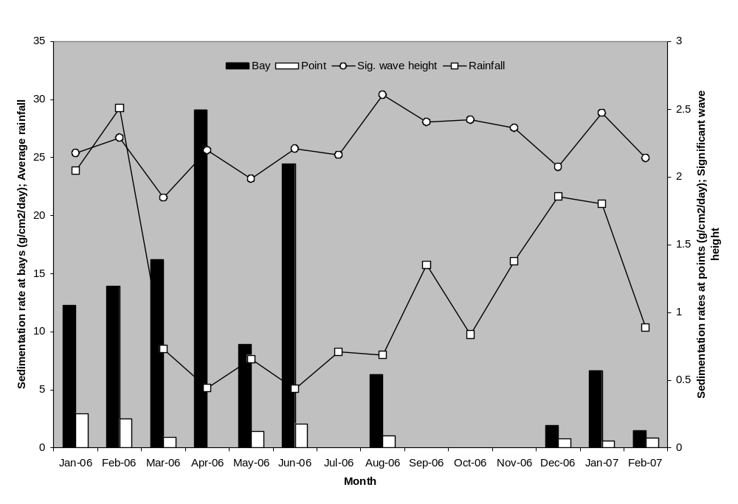

References
Clark JT, Herdrich DJ (1993) Prehistoric settlement system in Eastern Tutuila, American Samoa. The Journal of the Polynesian Society 102(2):147-185

